**1st November 2018**

**Aim:** To design and build a circuit that implements a quad NAND 7400 gate (four NAND gates in series) to create a logic gate that resembles an XOR gate. The truth table below is the table I aim to achieve.

|  |  |  |
| --- | --- | --- |
| A | B | Output |
| 0 | 0 | 0 |
| 1 | 0 | 1 |
| 0 | 1 | 1 |
| 1 | 1 | 0 |

**Analysis:** We were able to use DeMorgan’s theorem to establish an equation using only four NAND gates that would resemble the inputs and outputs of an XOR gate.

***F = A’B + AB’***

***By Boolean algebra…***

***F = ((A.(A.B)’)’.(B.(A.B)’)’)’***

**Logic Diagram:**

The logic diagram was inferred from the equation

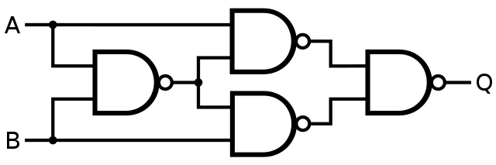

NAND gates in series to create XOR outputs

We used this diagram to guide the circuit creation process.

**Results:**

Table 1 - Truth Table for XOR Gate

|  |  |  |
| --- | --- | --- |
| A | B | Output |
| 0 | 0 | 0 |
| 1 | 0 | 1 |
| 0 | 1 | 1 |
| 1 | 1 | 0 |

These are the results of the experiment, gathered from the truth table of the respective XOR gate created.

**Conclusion:** We were able to successfully design and build a circuit that takes advantage of 4 NAND gates to create an XOR gate for our circuit.